

COMP7142 | COMP7142001

Popular Network Technology

Documentation Report

Assignment 1

[Insert Case Code Here (e.g. O203-COMP6844-XXYY-01)]

Document Information
Developer Information
Developers | Client
[Alief Rifki Fadilah]  [2702251144] | Software Laboratory Center  Bina Nusantara University  Jalan Kebon Jeruk Raya no. 27  Jakarta Barat, Indonesia
Development Period
[Insert Date of the Test Here]

Provision Infrastructure with Terraform
[Action Name]
Tools/Method Used | [Insert any tools used here]
Step-by-Step | [Insert step-by-step action is taken to do the action here]
Result | [Insert result screenshot here]
Description | [Insert the description of the result here]
Note: You may add more table if needed. For every action, you need to separate the report table.

Containerize the Application
[Action Name]
Tools/Method Used | [Insert any tools used here]
Step-by-Step | [Insert step-by-step action is taken to do the action here]
Result | [Insert result screenshot here]
Description | [Insert the description of the result here]

Note: You may add more table if needed. For every information, you need to separate the report table.

Create an Azure Container Registry (ACR)
[Action Name]
File Location | [Insert file location here]
Step-by-Step | [Insert step-by-step action is taken to do the action here]
Result | [Insert result screenshot here]
Description | [Insert the description of the result here]
Note: You may add more table if needed. For every action, you need to separate the report table.

Deploying the Application on AKS
[Action Name]
File Location | [Insert file location here]
Step-by-Step | [Insert step-by-step action is taken to do the action here]
Result | 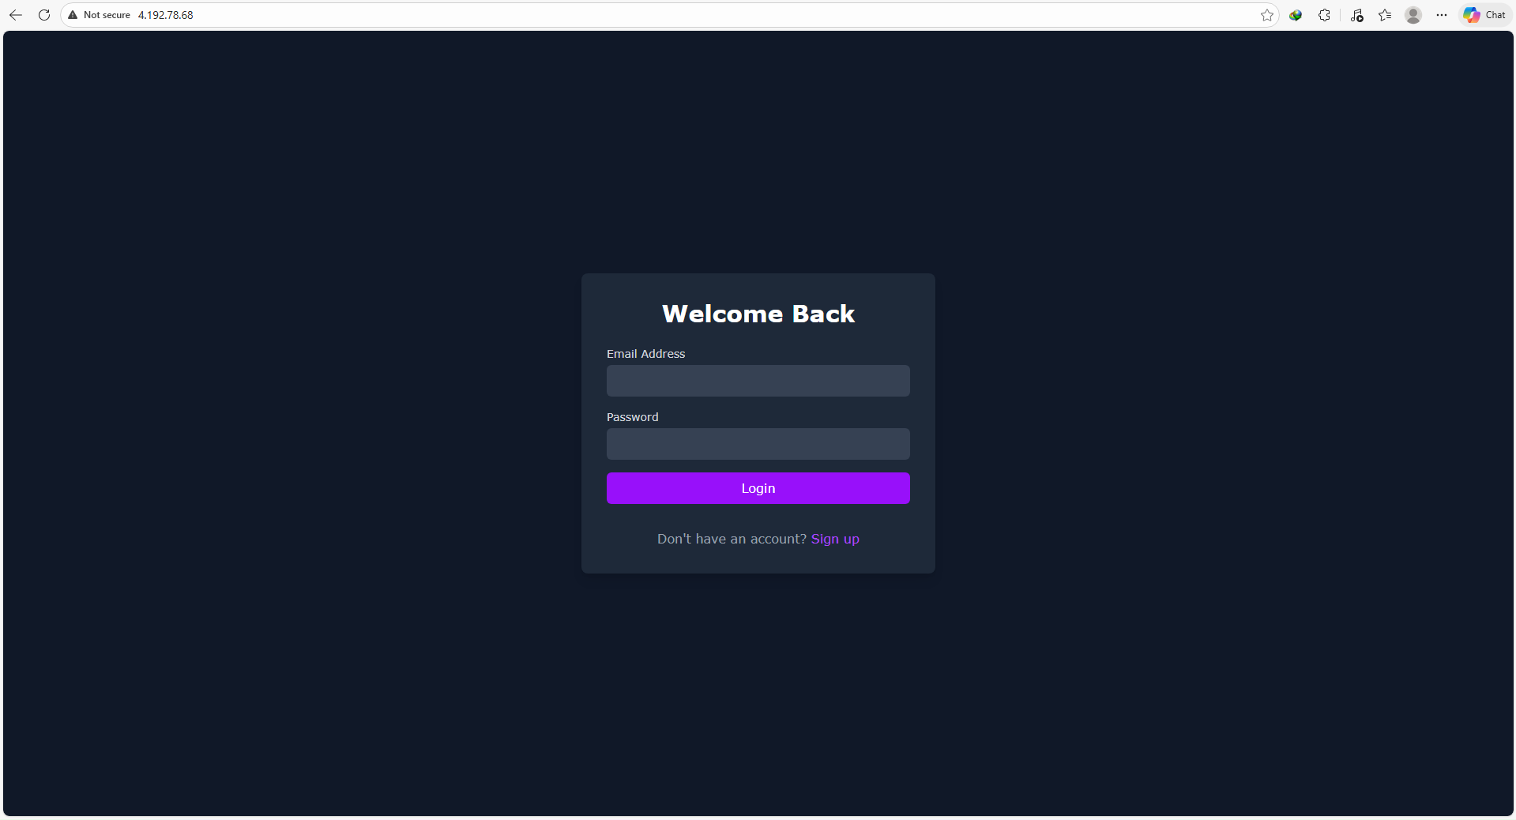
Description | [Insert the description of the result here]
Note: You may add more table if needed. For every action, you need to separate the report table.

